Customer Details
Full Name: xxxxxxxxxxxxx
Phone: xxxxxxxxxxxxx
Ghana Card Number: xxxxxxxxxxxxx

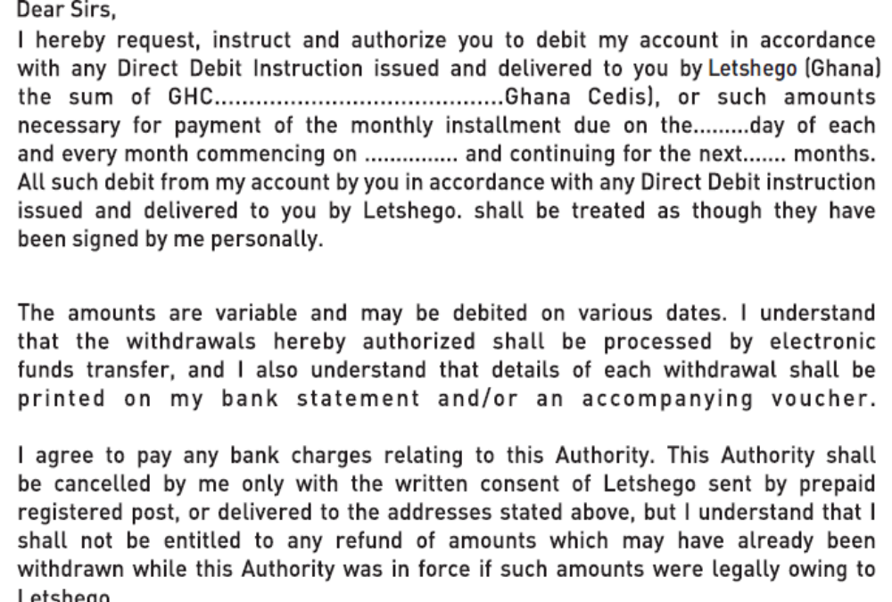

BANK DETAILS
Account Name Account Number Branch

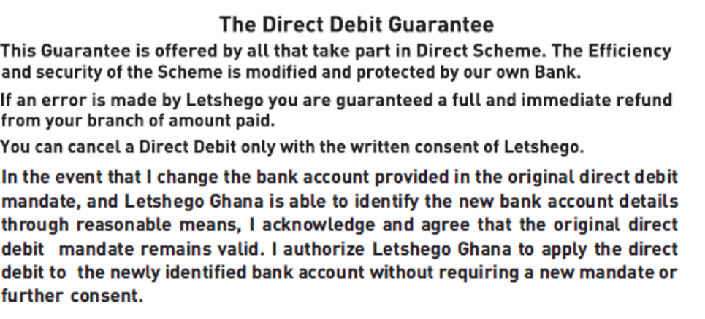

SIGNATURE AND DATE

